

|  |  |  |
| --- | --- | --- |
|  | **Model Development Phase Template** | |
|  |  |  |
| Date |  | 15 March 2024 |
|  |  |  |
| Team ID |  | PNT2022TMID124356 |
|  |  |  |
| Project Title |  | SmartLender - Applicant Credibility |
|  |  | Prediction for Loan Approval |
|  |  |  |
| Maximum Marks |  | 4 Marks |
|  |  |  |

**Initial Model Training Code, Model Validation and Evaluation Report**

The initial model training code will be showcased in the future through a screenshot. The model validation and evaluation report will include classification reports, accuracy, and confusion matrices for multiple models, presented through respective screenshots.

**Initial Model Training Code:**

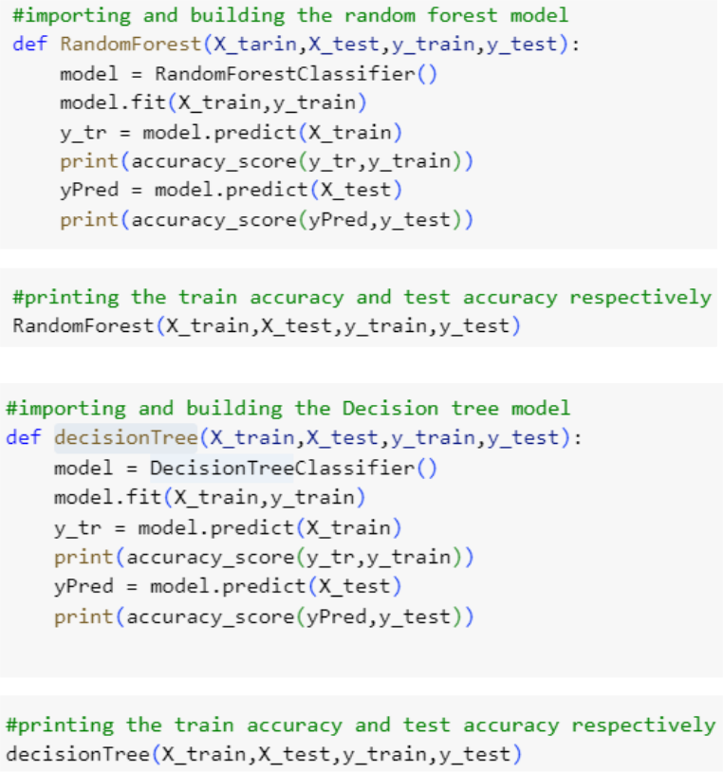

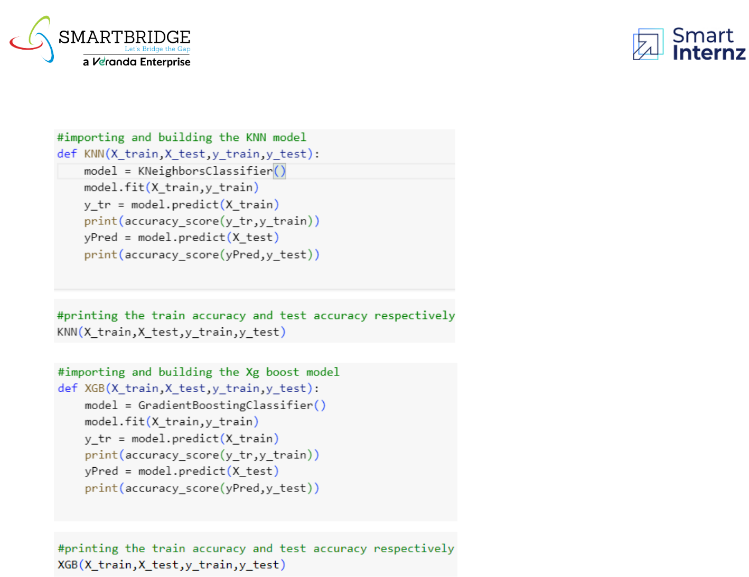

**Model Validation and Evaluation Report:**

|  |  |  |  |
| --- | --- | --- | --- |
|  |  | **F1** |  |
|  |  | **Scor** |  |
| **Model** | **Classification Report** | **e** | **Confusion Matrix** |

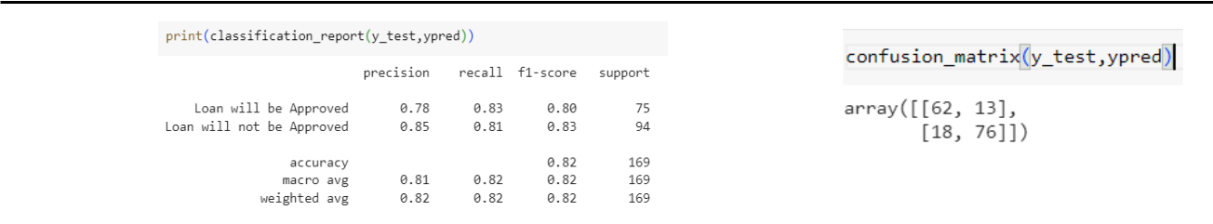

|  |  |  |
| --- | --- | --- |
| Random | 81% |  |
| Forest |  |
|  |  |

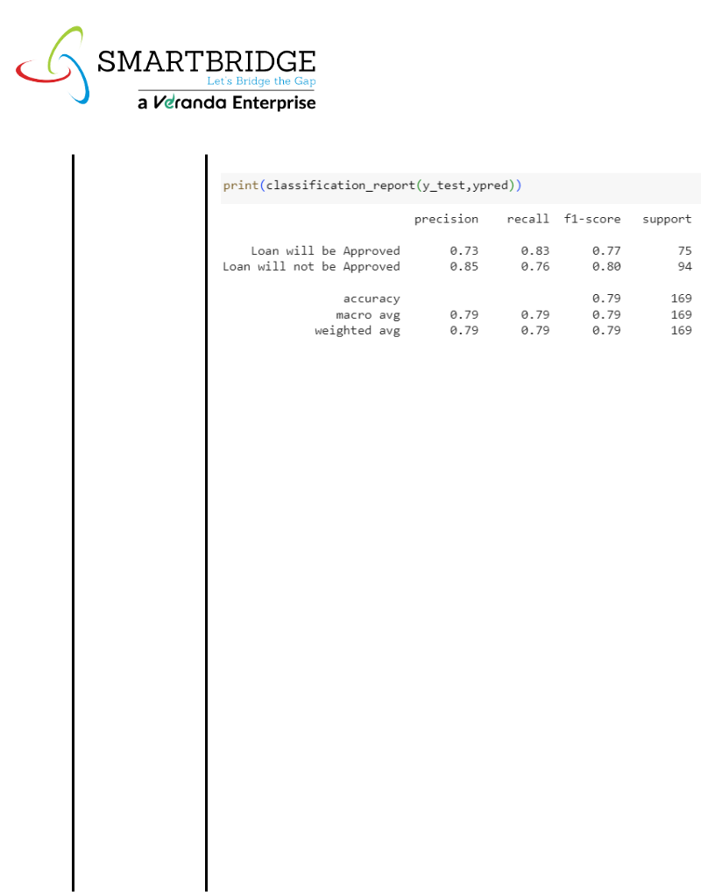

Decision Tree

KNN

Gradient Boosting

79%

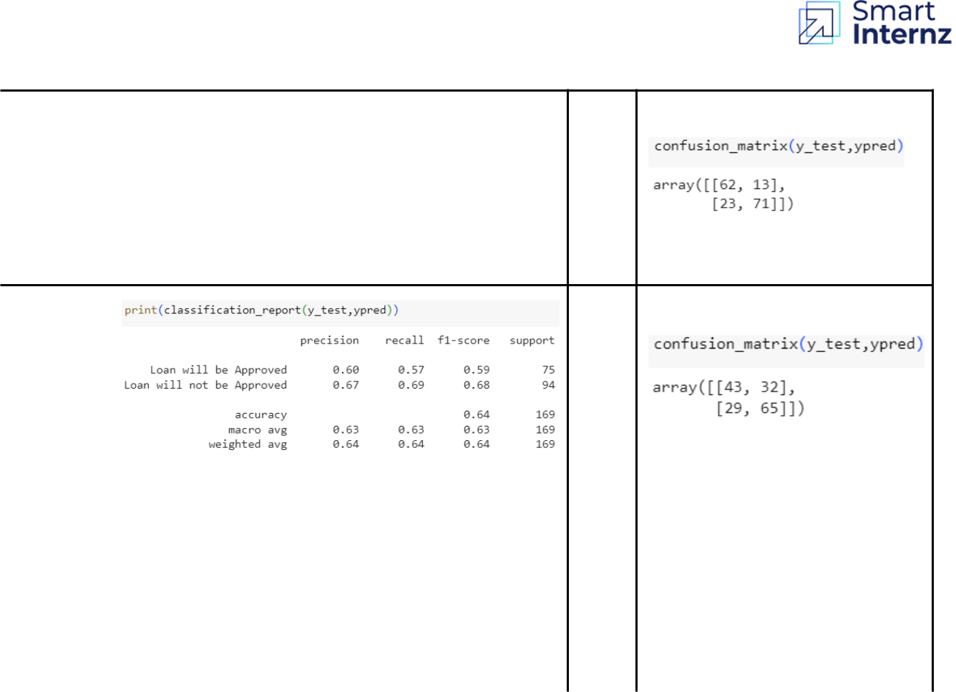

64%

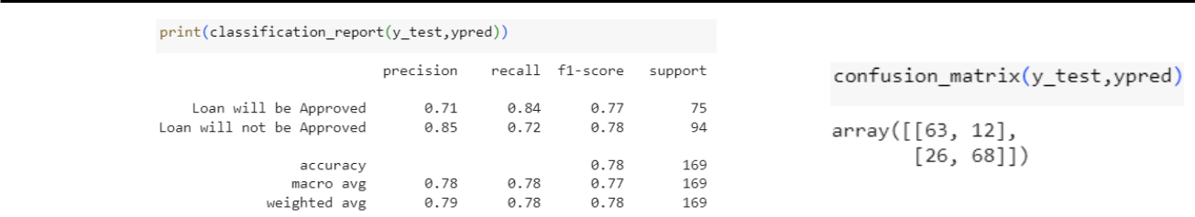

78%